

Melanie Sykes Endorses National #SaveOurBrassBands Crowdfunder Campaign

Campaign page: https://www.crowdfunder.co.uk/save-our-brass-bands

Brass Bands saw their main source of income disappear in an instant when they had to stop putting on performances in March in response to the Covid-19 pandemic. A significant loss in income over the Summer months, paired with necessary expenditure needed to make rehearsal spaces Covid compliant means that many Brass Bands are in a perilous financial situation.

Consequently, Crowdfunder and Brass Bands England have teamed up to launch #SaveOurBrassBands, a new national campaign to save hundreds of UK Brass Bands struggling to survive the Covid-19 pandemic. Campaign details were revealed at the recent Brass Band Conference, and Brass Bands England (BBE) are delighted to furthermore announce that the campaign will be led by broadcaster and baritone player, Melanie Sykes.
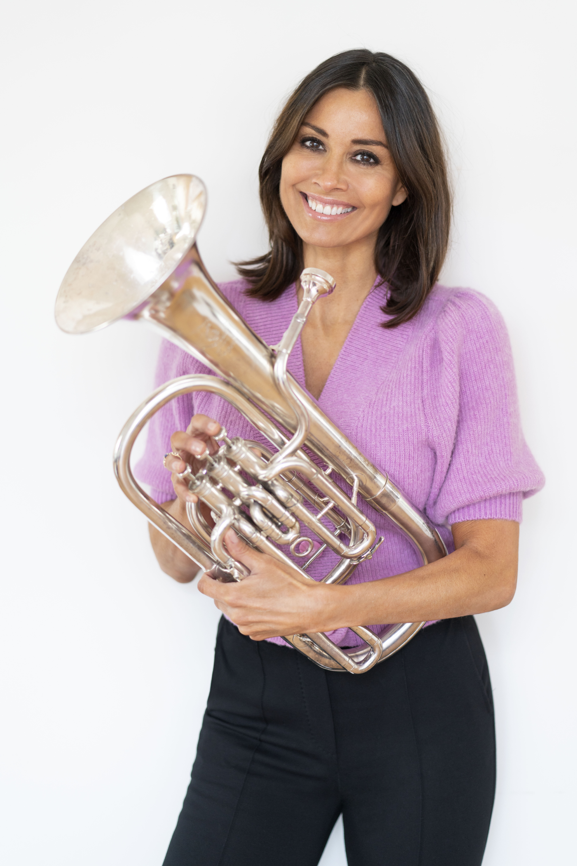
Photo Credit: Alan Strutt
The fundraising campaign will be hosted free of charge for all brass bands by the fundraising platform, Crowdfunder.co.uk. The aim is for every brass band struggling with the current economic climate to be able to create their own Crowdfunder page and to raise money in their communities to help their cause, but under the umbrella of the wider national campaign. Bands can make their free page here and add a range of unique rewards ranging from personalised Christmas performances through to delivering online lessons : https://www.crowdfunder.co.uk/save-our-brass-bands

The campaign follows the successes of previous #SaveOur…. style Crowdfunder campaigns, such as #SaveOurVenues and #SaveOurTheatres, which have raised over £3 million and £1.2 million respectively.

Speaking about her life in brass bands and the #SaveOurBrassBands campaign, Melanie Sykes commented:

“I’ve been involved in brass bands since I was about eight years old, and going to band as a child was a very good education on teamwork, sticking to rules, discipline to practice, communication and listening, but mostly it was fun! My father, Robert Sykes, is a brass bandsman, like his father before him, who was also a composer and conductor. My dad plays euphonium and conducts, and he taught me the basics on an old trumpet we had at home. He actually taught my whole family and did private lessons for others too.”

Looking back over her family’s banding career, Melanie continued:

“I played a cornet that belonged to Mossley St. John’s Band; my dad must have been with them at that time, but I didn't actually play with them. I really cannot remember when I first picked up the baritone. I desperately wanted to be a euphonium player, but alas it was a tad too big for me when I was a child and the baritone just stuck. I played mostly at Ashtonian Brass, a 4th Section band. My older sister, Samantha, played trombone, my little sister and my mum both played tenor horn, dad was on euphonium and I played baritone. I played with them until I was about 15 years old and I had a nice tone apparently - well that's what my dad always said - and obviously when I practised, I was quite good. I always had interesting passages, what my dad would describe as ‘a bit of fat’. I did, however, always hold fantasies about being a euphonium soloist like him and, to be honest, I still do!”

Speaking about banding highlights, Melanie added:

“I absolutely loved Whit Friday and I used to love marching. The competition side of it was a bit scary but it was so much fun too! I loved the community spirit and it was fantastic to be a part of that for a good few years there. I would still love to be in a band and if I could make rehearsals regularly, I would absolutely do it. I have an instrument at home and have a blow on it now and again, mostly at Christmas. I can still get a decent sound out of it, but my fingers take a bit of time to limber up and my lip is shot easily!”

When asked about the best thing about being in a brass band, Melanie replied:

“For me, being in a brass band meant spending time with my family, being part of a community, learning how to present myself, exercise a bit of showmanship and, in competition, how to handle my nerves!”

BBE’s Chief Executive Officer, Kenny Crookston commented on the campaign:

“Save Our Brass Bands is open to all bands in the UK, which will have access to the online platform free of all charges for the duration of the campaign, as well as some brilliant resources provided by Crowdfunder to help them maximise the return on their efforts. The real benefits of the campaign will be seen when as many bands as possible get involved and we can help to raise the profile of the existential issues facing brass bands at the current time. We are delighted to welcome Melanie Sykes on board to help us do this and hope that every band in the country will consider the benefits of getting on board to help both themselves and each other raise as much cash as possible!”

#SaveOurBrassBands national campaign will run from 17 November to 18 December. Further details of the campaign, including recordings of group coaching webinars and campaign support materials, are available on the BBE website at: https://www.bbe.org.uk/what-we-do/crowdfunder-saveourbrassbands

For more information or press enquiries, please contact:
Name: Lucy Lomas. Phone: 07867 306842 Email: lucy.lomas@crowdfunder.co.uk

About Crowdfunder.co.uk:

Crowdfunder exists to tackle society’s challenges. That’s because we believe in the power of the crowd to make positive change happen. By providing a platform for people to pair online donation with powerful campaigns and community engagement, we’ve seen our crowd and Crowdfunders do some spectacular things. From saving community centres to reimagining their high streets to influencing national policy. If you’ve got a good idea, this is where you can make it happen.

To date, over £150 million has been raised on Crowdfunder by thousands of businesses, social enterprises, charities, community groups, and individuals across the UK.

About Brass Band England:

Brass Bands England is the Arts Council England’s sector support organisation for brass bands at all levels. We deliver training, provide access to discounts and give bands a voice.

