Instructions for accessing the BBE BOPA
Members of BBE can use the BBE BOPA to print off a Child Performance Licence provided certain conditions are satisfied.
The person in your band who is the band admin for your BBE website band account will be able to look at their ‘My Group’ dashboard to find out whether everything is in place to use the BOPA.
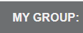
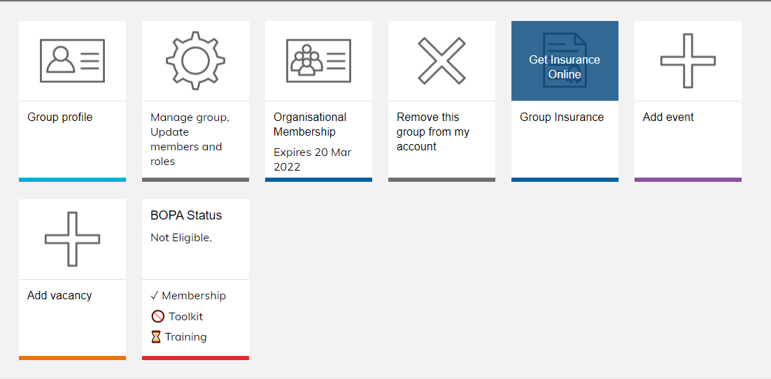
The BOPA Status tile shows whether the band is eligible and works on a traffic light system. If it is eligible it will be highlighted in green and another BOPA tile will appear next to it. Click on this, fill in the details, print it off and send to the appropriate local authority. If you tick ‘public event’ your event will be advertised on the BBE website under Events.
However, if the BOPA status tile in highlighted in red and a BOPA tile is not showing next to the BOPA Status tile, then the band has not met all the necessary conditions. If the BOPA status tile is highlighted in amber then you can still use the BOPA but some of the conditions will soon need some action.
In the example below, the tile has a red line under it because not all the conditions have been met:
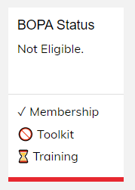
Membership = current

Toolkit = red (Your band has not reviewed your safeguarding policy using the
BandSafe Tookit in the last 18 months)

Training = amber (Your band’s BandSafe training is within six months of expiry. BandSafe training is valid for two years and you must have two trained members to continue to use the BOPA).
To satisfy the conditions for using the BOPA you may need to do some or all of the following:
Membership
The band needs to have current membership of BBE – if you have a query about your membership renewal email member@bbe.org.uk or go to Join BBE if your band is not a member.
BandSafe Toolkit
This is an online form to complete to show that you have satisfied all areas of safeguarding. See the BandSafe website page for more information.
To complete the Toolkit you can access this from your own dashboard – BandSafe Self-Assessment Toolkit (see image below). You need to be given admin rights from your band admin to do this.
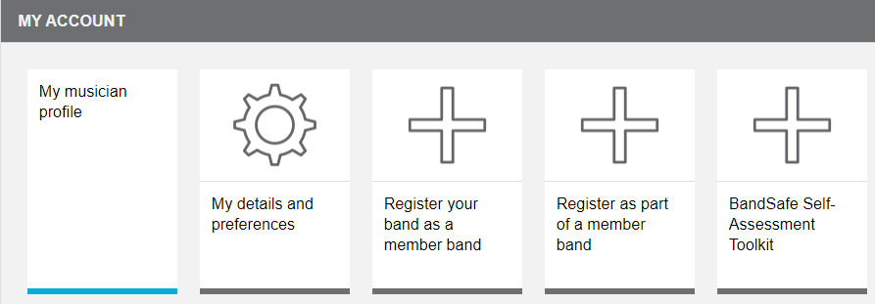
Training
Two people need to have completed the BandSafe Training within the last 2 years. They need to have set up a personal account for themselves on the BBE website and be linked to their band. To do this:
Go to the BBE website
Click on Member login / Create account (top right-hand corner)
Create new account
Add your own personal email address and complete all the fields marked with a *. Make up a password. Use ‘I’m not a robot’ and create an account.
IMPORTANT: everyone needs to have their own individual account with a unique email address. You should not share a band account.
Go to ‘My Account’ (see image above).
Click on ‘Register as part of a member band’ and start typing in the name of your band. This will send an email to your band admin asking them to approve you as a member of the band. It is best if the band admin gives you admin permissions.
(If you don’t do this your training will not be recognised as being associated with your band and you won’t be able to use the BOPA).
If you have done all of the above or have any problems along the way you can email:
sam@bbe.org.uk or rosie@bbe.org.uk or telephone 01226 771015

